Team Structure, Roles and Resonsibilities

The Cambria team is an agile, user-focused and multidisciplinary team that is structured slightly different than a traditional waterfall project’s team structure. Cambria’s agile team structure comprises an agile coach, delivery manager, product manager, development team, business team, and stakeholders. The roles making up the team are as defined by agile labor categories.

The Cambria Agile Team Structure

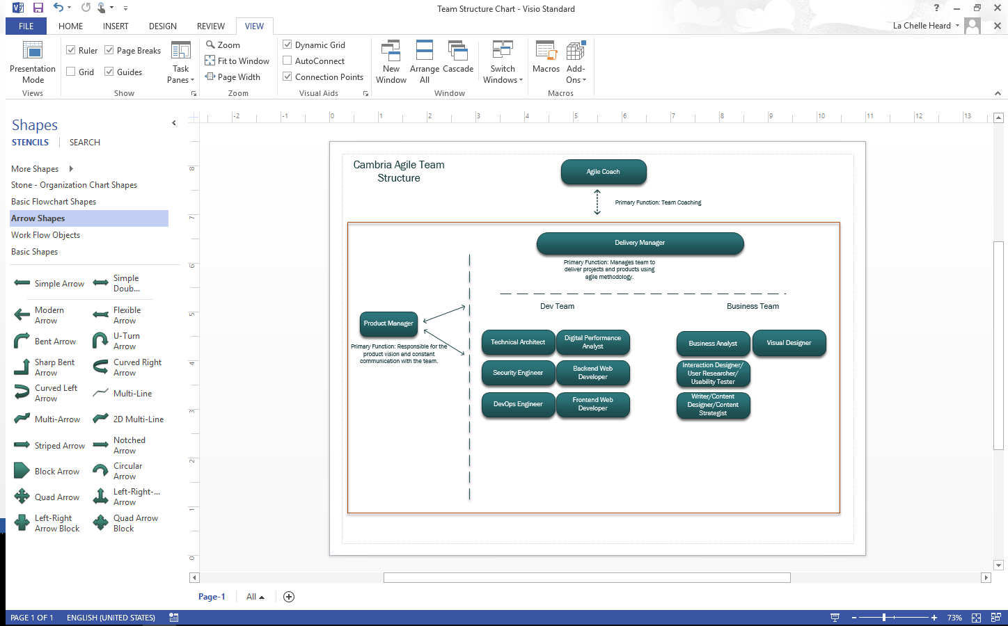

The team assembled represented diverse backgrounds including a few resources working remotely. Those involved included developers, visual designers, business analysts, technical architects, managers, writers, users and Product Managers. The roles were assigned based on each individual’s experience, skill sets, background, interest and the specific needs of the prototype.

Cambria Agile Labor Category Assignments

|  |  |  |  |
| --- | --- | --- | --- |
| Role | Responsibility | Staff | Corresponding Agile Labor Category |
| Agile Coach | Transforms initiatives to deliver lasting change within agencies focusing on delivering value for clients. Embeds an agile culture using techniquies from a wide range or agile and lean methodologies and framework. Helps to create an open and trust-based environment, thus enabling a focus on delivery and continuous improvement. Develops clear lines of escalation, in agreement with senior managers. | Dhiraj Talwar | Category 1 |
| Product Manager | Manages the delivery, ongoing success and continuous improvement of one or more digital products and/or platforms. Defines and obtains stakeholder buy-in for product definition and delivery approach. Creates effective, prioritized product descriptions, and delivery plans to meet user needs in a cost-effective way. Interprets user research in order to make the correct product decisions. | Anand Adoni | Category 2 |
| Delivery Manager | Utilizes the agile project management methodology to deliver projects and products. Works with the product manager to define the roadmap and translates into user stories. Ensures all products are built to an appropriate level of quality. | Rajesh Adoni | Category 3 |
| Business Analyst(s) | Works closely with the Product Manager to define a product approach to meet the specified user need. Rationalizes complex information to make it understandable for others to work with. | Lauren Schaub  Denise Tugade  Zach Ulhaq  Erik Newland  Venkata Nuli  Casey Skinner | Category 4 |
| Technical Architect(s) | Architects the overall system, by using prototyping and proof of concepts. Uses version control systems, specifically GitHub. Develops product roadmaps, backlogs, and measurable success criteria, and writing user stories. | Rich Cefola  Sandeep Koppolu | Category 5 |
| Security Engineer | Performs security audits, risk analysis, application-level vulnerability testing, and security code reviews. Develops and implements technical solutions to help mitigate security vulnerabilities. Conducts research to identify new attack vectors. | Rich Cefola | Category 6 |
| Backend Web Developer(s) | Responsible for server-side web application logic and integration of the work of the frontend developers. Write the web services and APIs used by front-end developers. | Shibu Sreedharan  Yagna Jilakara  Sandeep Koppolu  Hitesh Kumar | Category 9 |
| Frontend Web Developer(s) | Responsible for the technical design, transforming functional designs (mockups) into working frontend functionality and working with other developers and testers to implement the frontend application. | Shibu Sreedharan  Yagna Jilakara  Sandeep Koppolu  Hitesh Kumar | Category 10 |
| Visual Designer | Responsible for managing project design reviews, resource planning, and execution for all project work related to visual design. | Rich Cefola | Category 11 |
| Interaction Designer(s) / User Researcher(s) / Usability Tester(s) | Conducts user research, analysis & synthesis, persona development, interaction design, and usability testing. | Denise Tugade  Erik Newland  Zach Ulhaq  Venkata Nuli  Casey Skinner | Category 12 |
| Writer(s) / Content Designer(s) / Content Strategist(s) | Collaborates with team to help develop and maintain the appropriate voice for content produced and helps develop the strategy and execution of content across digital channels. | Erik Newland  Denise Tugade  La Chelle Heard  Venkata Nuli | Category 13 |